Ideation Phase
Define the Problem Statements

Date | 25 June 2026
Team ID
Project Name | An employee requests installation of licensed software through the Service Catalog
Maximum Marks | 2 Marks

Customer Problem Statement Template:
Employees in many organizations experience delays and a lack of transparency when requesting licensed software through manual processes such as emails or phone calls. These methods make it difficult to track request status, manage approvals, and assign installation tasks efficiently.
The organization requires an automated solution that allows employees to submit software installation requests through the ServiceNow Service Catalog, enabling streamlined approvals, automated task creation, real-time tracking, and faster software delivery while improving the overall user experience.

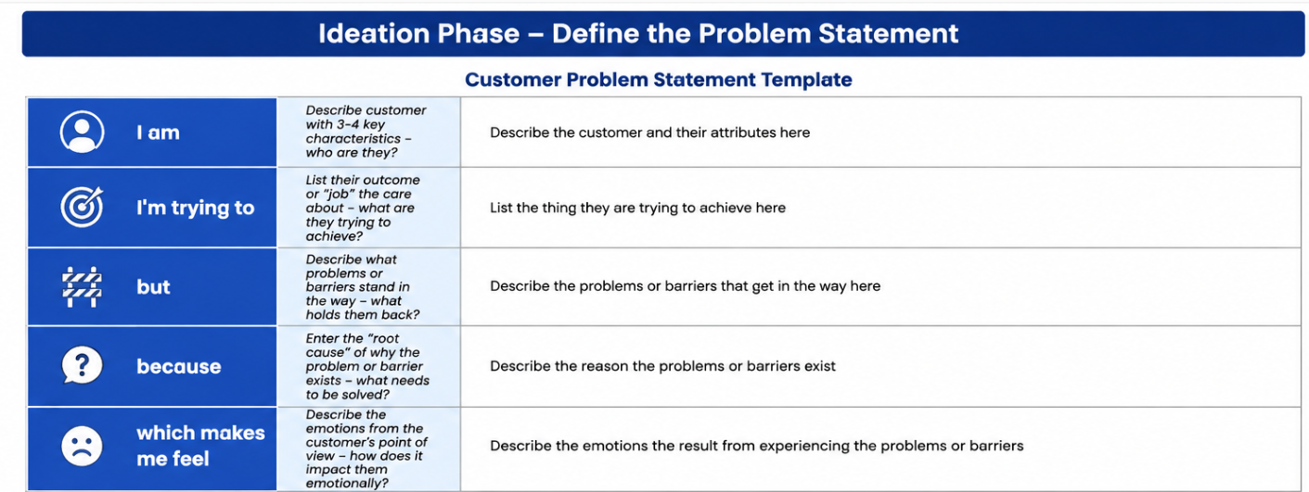
Reference: https://miro.com/templates/customer-problem-statement/

Example:
